

List of recommended hotels
in Gdansk
and
a map of Gdansk

You can find all Gdansk hotels in Gdansk hotel directory which is updated every day and will provide you with the most accurate information about accommodations in Gdansk hotels:

www.travelpoland.com/index

http://www.travelpoland.com/index.php?pid=102

By using Poland biggest online hotel database you will able to check availability and rates for all Gdansk hotels. The site offers a wide selection of hotels in Gdansk Poland which are ideal for business and leisure traveller. Gdansk luxury hotels to budget cheap hotels in Gdansk - with great discounts and special deals are offered to you in Gdansk hotel to suite your budget.
Hotel name | Standard | Localization
Angela | ** | Near Centre
Bartan | *** | Seaside
Dom Muzyka |  | Centre
Dwór Oliwski | ***** | Near Centre
Hanza | **** | City Center
Krolewski | *** | Centre
Lival | *** | By the sea, near city centre
Mercure Hevelius Gdansk | *** | Centre
Moris Hotel | ** | Seaside
Novotel Gdansk Centrum | *** | Near Centre
Novotel Gdańsk Marina | *** | Seaside
Palac w Leznie
Podewils | ***** | Centre
Posejdon | *** | Near Centre
Stara Karczma - Pension |  | Seaside
Szydlowski | *** | Centre

Posejdon


Near Centre
The hotel is situated 100 m from a sandy beach. The hotel stands just by the walkway, joining the Sopot pier with the Jelitkowo quarter of Gdansk. The hotel is surrounded by a park. Airport 12 km, railway station 2.5 km. This hotel has the closest location to the International Trade Fair in Gdansk - only 2 km.
Hotel offers 145 double rooms (24 joint-rooms, ideal for families), 2 suites. Each room is equipped with satellite TV, radio, direct-dial telephone; room service, non-smoking rooms.
News-stand, flower shop, small gallery with handicraft art, laundry, shoeshine machines, guarded parking area, pets permitted. Hotel taxis. Private Garden, garden parties, indoor swimming pool, separate pool for children, sauna, solarium, fitness centre, massage, jacuzzi, mini-golf, casino at 3 km from the hotel. Bonfire place.
"Clio" Restaurant serves Polish and International cuisine, "Continental" Cocktail Bar, "Hades" Night Club, terraces and summer terraces, barbecue in summer. Buffet breakfast. Vegetarian and dietary food available.
Angela

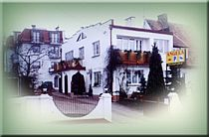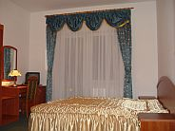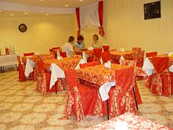
Near Centre
We have a real pleasure to recommend You our beautifully located in the quiet district of Gdansk new Hotel Angela. The object is situated about 6 min by bus from the Old Town, sea and Central Station in Gdansk. About 20 min. from the airport and Gdynia city.
The Hotel offers 55 beds in single, double and triple rooms, studio and suites. All fully equipped with bathrooms, hair dryers, satellite TV and radio. The interiors of the rooms are cosy and comfortable, so the hotel is a perfect place for rest and relaxation.
There is a guarded parking for all guests.
We highly recommend our breakfast buffet. There is also a full abroad possibility in our restaurant.

Bartan
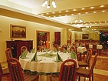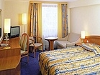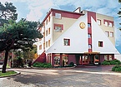
Location
Seaside
The Bartan Hotel is a cosy, family managed hotel in Gdansk. It is located in a seaside district of Gdansk, on the picturesque Sobieszewo Island, 800 m away from a sandy beach, 20 min. drive to the city centre. Peaceful surroundings, pleasant atmosphere and excellent service ensure your good rest and relaxation.
Our hotel offers 30 comfortable rooms with modern furnishings. Every room is equipped with: bathroom with hairdryer, satellite TV, telephone, radio and Internet connection. The rooms located on the topmost, third floor offer a marvelous view of the Vistula River and the surroundings of the Sobieszewo Island. For your convenience, an elegant lift has been put in.
Sauna, jacuzzi, billiard table, mountain bikes, horse riding - 3 km.
Serving continental cuisine, "Bursztynowa" Restaurant has got 80 seats at our Guests' disposal. The Restaurant makes a great impression by virtue of its interior decoration, delicious and diversified menu as well as top-quality service. In summer, it additionally offers seats located on the adjoining terrace, with a grand view of the garden. Apart form this; there is a café with a billiard table and a bar (open round the clock).
Dom Muzyka

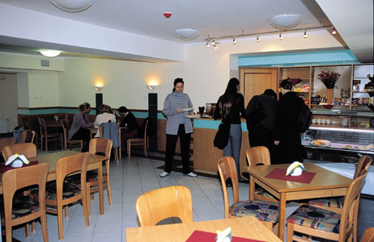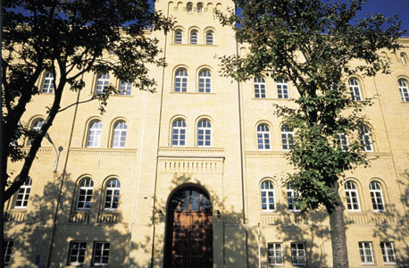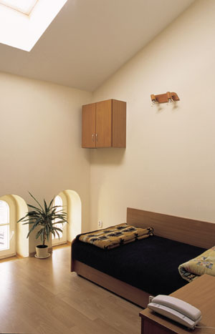

Centre
DOM MUZYKA Hotel (Musician's House) is very conveniently and attractively situated within 5 minutes walking distance of the centre of the picturesque Old Town of Gdansk. Still it is located in a very peaceful and pleasant area, far off noise and traffic. A great, equally comfortable and yet much cost-saving alternative to Gdansk's big hotels.
There are 58 very comfortable and fresh single, double and triple rooms, all cosy and nice, perfectly equipped with a phone, fridge and a TV-set (in single rooms).
There is a 24h guarded car and bus parking space, 24h monitoring of the entire hotel premises, barbecue facilities.

Dwór Oliwski

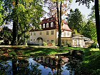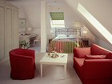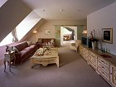
Near Centre
The location of The Dwor Oliwski in the beautiful woods of The Tricity's Landscape Park makes this place perfect for a rest with the family or for business purposes. It also provides, on one hand, for peace and calm and, on the other, for a close proximity to the centre of the city which makes the Inn fast and easy to reach.
Each room is beautifully furnished and equipped with a mini bar, satellite TV, a radio, air-conditioning, broadband Internet connection and an elegant bathroom. The Presidential Suite (over 60 m2) encompasses four rooms: a living room, a bedroom, a bathroom and a toilet. It is equipped with period furniture and modern facilities which include broadband Internet connection, a mini bar, a safe and satellite TV.
We invite you to Dwor Oliwski complex: hotel, restaurant, cosy Tea Room and Bar, charming Wine Cellar and large colourful gardens. Two hotel buildings with unique thatched roofs encompass 40 elegant guest rooms, including three Junior Suites and one Presidential Suite.Health and Fitness Centre provides swimming pool, fitness gym, saunas, solarium and masseur service. Private secured parking is at our guests' disposal 24 hr a day.
The Dolina Radości valley, Oliwa, in a restored Inn of the XVII century, is located a restaurant, bar and tea room and in the Cellar a wine Bar. Restaurant offers dishes of French, Polish and International cuisine. The Bars serve alcoholic beverages, teas, snacks and delicious desserts. Our French chef and pastry chef will surprise you with a perfect taste of dishes and cakes. There are organized tasting of the best wines from all over the world. In our coloured areas we organize banquets, conferences and occasional receptions for companies and individuals. We also offer professional outside catering.
Hanza

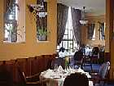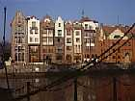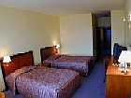
City Centre
Hotel Hanza is located on the most beautiful places in the Main Town. Modern and luxurious hotel opened in 1997 is with its facade designed to blend in the neighbouring buildings.
Hotel Hanza offers 53 rooms and 7 suites with bathrooms, satellite TV, mini-bar, telephone, internet access. There is also an internet W-LAN connection.
Fitness centre with sauna and jacuzzi, guarded car parking, hairdresser.
Restaurant serves Polish and international cuisine with its specialties of fish.

Krolewski

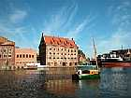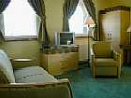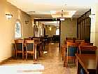
Centre
The brand new Krolewski Hotel is situated in the centre of the old part of Gdansk Region, by the river Motlawa. High standard, good location and nice service makes your stay unforgettable. Traditional and comfortable rooms assures rest and relaxation in 30 single and double spacious rooms fully equipped with satellite TV, telephone and internet link.
Lival
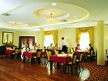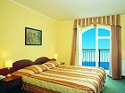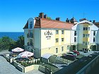
By the sea, near city centre
The place has a few advantages. First of all, due to its highly attractive location. The hotel is a quiet oasis - just by the sea, only 10 meters from the sandy beach and bicycle path as well as a jogging trail running along the beach. Just a short trip from the historical Old City, the advantages of the city and seaside are combined. The hotel offers 35 comfortable rooms enabling accommodation for 76 people in 30 cosy rooms and 5 studios. All rooms have windows with marvellous view of the sea, wide sandy beach and nearby harbour. Rooms are equipped with a comfortable bed, private bathroom, satellite TV, direct dial telephones, individually controlled air conditioning, mini-bar. Drivers can leave their cars safely in the guarded parking lot just in front of the hotel. Hotel guests can relax in beer garden or hotel patio in summer months. If they want to relax they are also welcome to our sauna or to pay a visit to our fitness club. Our elegant restaurant specializes in both national and international cuisine, offering delicious food for every mood.
Mercure Hevelius Gdansk

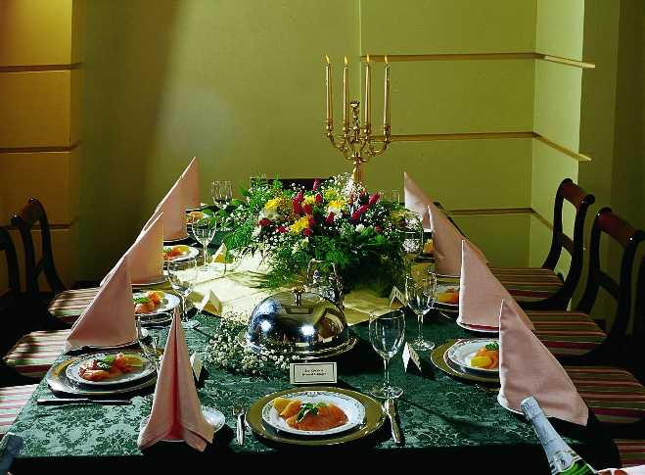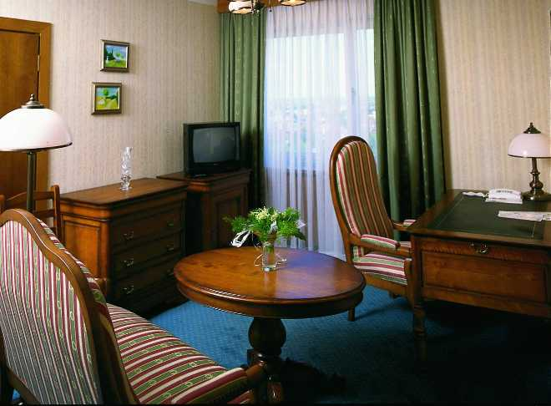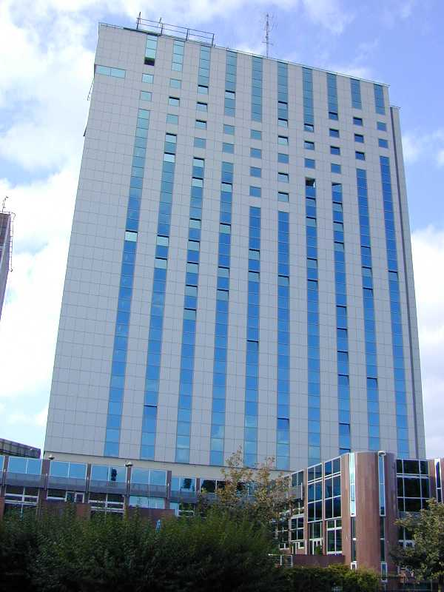
Centre
The hotel is situated in the heart of the Old Town of Gdansk, close to the railway and bus stations, 15 km from Rebiechowo airport, a five-minute walk from the city cultural and commercial centre. Hotel offers 93 single rooms, 182 double rooms, 6 suites. Each room is equipped with satellite TV, radio, direct-dial telephone, room service, non-smoking rooms. 17 rooms of business standard equipped with trouser - press, internet access, coffee and tea making facilities. Currency exchange, hairdresser, flower shop, news-stand, perfume counter, laundry, shoeshine machines, travel service office, outdoor car parking. Restaurant serves European and Polish cuisine, "Polaris" Coffee Shop, "Astro" Night Club, Bar, "Wega". Continental and buffet breakfast. Vegetarian food on request.
Moris Hotel

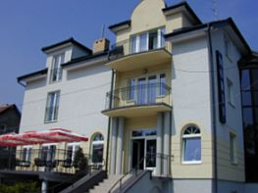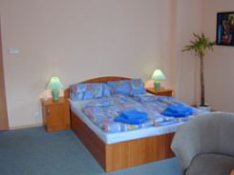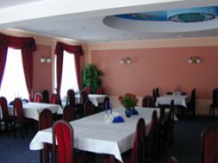
Seaside
Hotel Moris is situated in Gdańsk Jelitkowo near the boarder with the city of Sopot. It is a small seaside suburb, with unique and unforgettable atmosphere. It takes you only 3 minutes on foot to see splendid view of our Baltic Sea, to relax on the sandy beach and to feel enjoyment in every activity you take. In Jelitkowo there are lots of things to do and see.
Our hotel is newly built. It offers twelve double and triple rooms and apartments. It can be described as modern and comfortable inn. We know that it will satisfy even he most fussy guests If you feel like spending the time actively you can just hire the bike and ride 20 km along the beach on newly built bike path, go to the tennis court, or play mini golf. You can also choose to learn windsurfing, hire the motorboat, or just swim in the guarded waters of Baltic Sea. If you feel like seeing historic places can go to Gdansk. It on takes you about 25 minutes by tram to see 1000 years old city. We invite you to the theatres, museums, operas. You can wander along "Dluga" Street, visit churches; feel the atmosphere of beautiful buildings and streets of old Town.
Novotel Gdansk Centrum

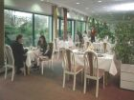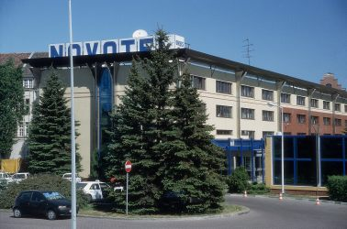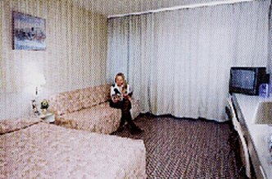
Near Centre
Situated on the Granary Island - the historical part of Gdansk, several paces away from the Old Town, 500 m from the city centre with its cultural background tastefully interspersed with commercial activities. Airport 15 km, Railway Station 1.5 km. 150 double rooms, some of them overlooking the Old Town. satellite TV, direct-dial telephone, room service. 1 room for disabled people, 60 rooms for non-smokers. Hairdresser, news-stand, laundry, dry-cleaning and pressing service, shoeshine machines. Pets permitted. Outdoor and indoor parking. Hotel taxis. Private garden, tennis courts at 7 km. "The Garden Brasserie" restaurant serves traditional Polish and International cuisine, Cocktail Bar, Summer terrace. Buffet breakfast.
Novotel Gdańsk Marina

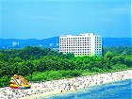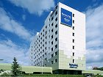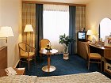
Seaside
The Hotel is situated on the bank of Gdańska Bay (30 m from the beach), 2 km from the centre of Sopot, 5 minutes walk from main road Gdańsk-Gdynia. The hotel is situated 14 km from the Rebiechowo Airport. The hotel offers 10 single rooms, 137 double rooms, 13 studio rooms, 2 suites and 1 office apartment. All rooms with a view on the Baltic Sea cost. There are satellite TV, film channels, radio and telephone in all rooms. Business rooms are additionally equipped with mini bar, tea and coffee sets. The hotel organizes trips, books guides, rents cars and mobile telephones. Hotel invites to hairdresser room, news-stand, disco, casino, indoor pool, sauna, solarium, billiard, bowling room, hydro- and classical massage. Guests can also use guarded car parking, 2 garages, tennis courts, bicycle rental place, basketball and volleyball field. There is a beach and mini golf field near the hotel.
Hotel's restaurant serves Polish and international meals á la Carte. The hotel invites also to "Green" Bar, "Bowling" Bar, Night Club "Atlantyda", Grill Bar "Cave" (from May to September).
Palac w Leznie

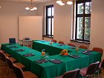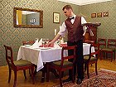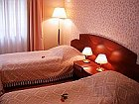
The Palace is situated close to Gdansk, merely 6 km from the international Lech Walesa Airport, and 6 km from the Tri-City ring road. A location like this is a guarantee of a quick and convenient connection with the whole Tri-City, and the vicinity of woods provides peace and quiet. The 18th century Palace and park complex at Lezno is a place for people searching for something unique. People who look for quietness and peace in stylish surroundings, for those of you who want to reconcile beauty and business. The Palace was erected in 1720 at the commission of Count Jan Przebendowski, a Royal Treasurer, and an eminent figure of public life. Afterwards, up until 1945, for more than a century the estate had been the property of the Hoenes. During their ownership one of the most beautiful landscape parks in our Region was founded. The University of Gdansk has been the owner of this historical estate for 10 years; the University carefully refurbished the Palace and furnished from the scratch completely cleaned out interiors.
The Lezno Palace offers 24 rooms: 8 suites of rooms, airy and spacious, arranged in the Biedermayer style; 16 standard rooms. All rooms are furnished with the Internet access, satellite TV, the telephone and the bath with shower.
A beautiful park, perfect both for taking a rest, and for arranging corporate banquets or weddings. A beautiful garden with more then a-hundred-year-old trees is illuminated by lamps, and its alleys lead to a dancing podium and garden-houses with a bar and a barbecue.
A restaurant serving excellent Polish, old Polish and European cuisine. The restaurant is located in a stylish interior, decorated with original prints, pictures, and numerous Biedermayer artefacts.
Podewils

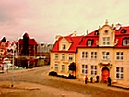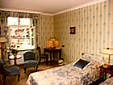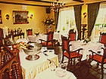
Centre
Year 2004: Winner of the international prize for tourist hotels and catering branch "TROPHY FOR THE YEAR 2005" awarded by Publishing House with cooperation with Trade Leaders Club for top achievements in tourist hotels and catering services. First place on the "Top Five" list in a well known and prestigious American Tourism Publication "Easy Escapes" for year 2003.The top standard of our services, superb location in the centre of Gdańsk Old City next to the Marina, the indoor arrangement with a style and exquisite cuisine make your stay in Hotel Podewils an unforgettable experience. Hotel Podewils is a place where history and tradition have been combined with modern life style and the best of comfort.
Every room has its own unforgettable atmosphere. All room are equipped with antique furniture, satellite TV with DVD, 2 telephone lines, air-conditioning, safe, mini-bar and very comfortable, nice bathrooms. Unlimited internet connection.
Restaurant - very elegant and romantic place. Furnished with antiques. A fireplace inside. Nice view of Motlawa river. Nice, not too loud jazz music. Fresh and very tasty dishes Polish and European style.
Stara Karczma - Pension

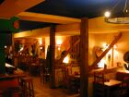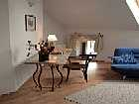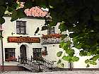
Seaside
A family-run, cosy STARA KARCZMA Pension (the name meaning "The Old Inn") is very picturesquely and attractively located in the very heart of the famous historic part of Gdansk called OLIWA, renowned for its beautiful Baroque cathedral and organ concerts. It neighbours the Tri-City Landscape Park and features easy access. 9 twins, 1 double room, 2 studio rooms with a kitchenette, 1 studio 2-room apartment and 1 studio 3-room apartment, all with a kitchenette. All the rooms are very comfortably and stylishly furnished, some feature old style wooden or iron beds, bathrooms with showers or bathtubs, satellite TV and radio. A cosy restaurant and a café, buffet breakfast.
Szydlowski

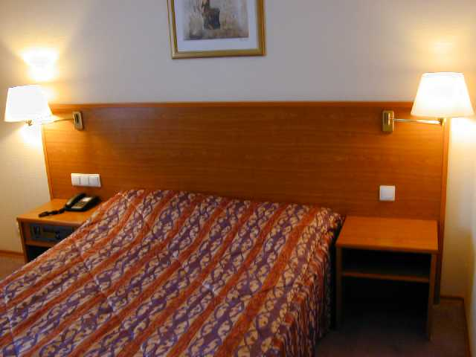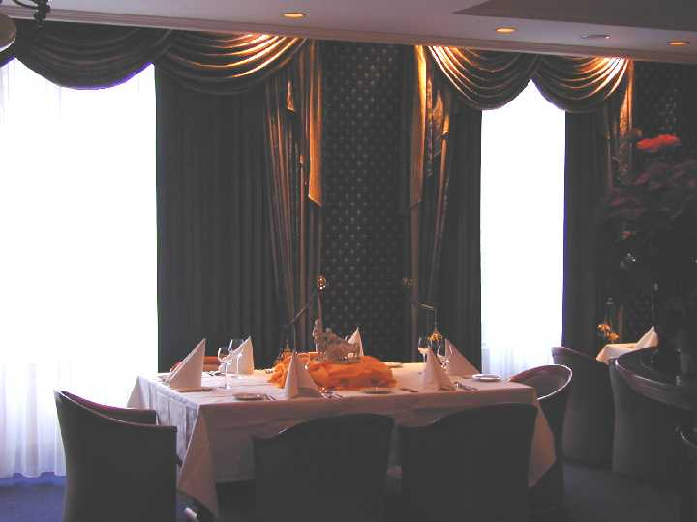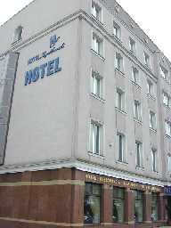
Centre
The 3-star Szydlowski hotel is a brand-new hotel located in Gdansk-Wrzeszcz near the main road connecting Gdansk, Sopot and Gdynia and short distance from the Gdansk-Wrzeszcz railway station (300 m) and the airport (10 km). Hotel offers 21 double, 9 single rooms, 2 mini and 3 deluxe suites. All the rooms with bathroom, satellite TV, radio, telephone and air-conditioning. Cake shop. Hotel's restaurant serves dishes of Polish and international cuisine.

All the hotels could be booking through the web-site directly.

For transport information, please, look in:

http://www.staypoland.com/tricity_transportation.htm

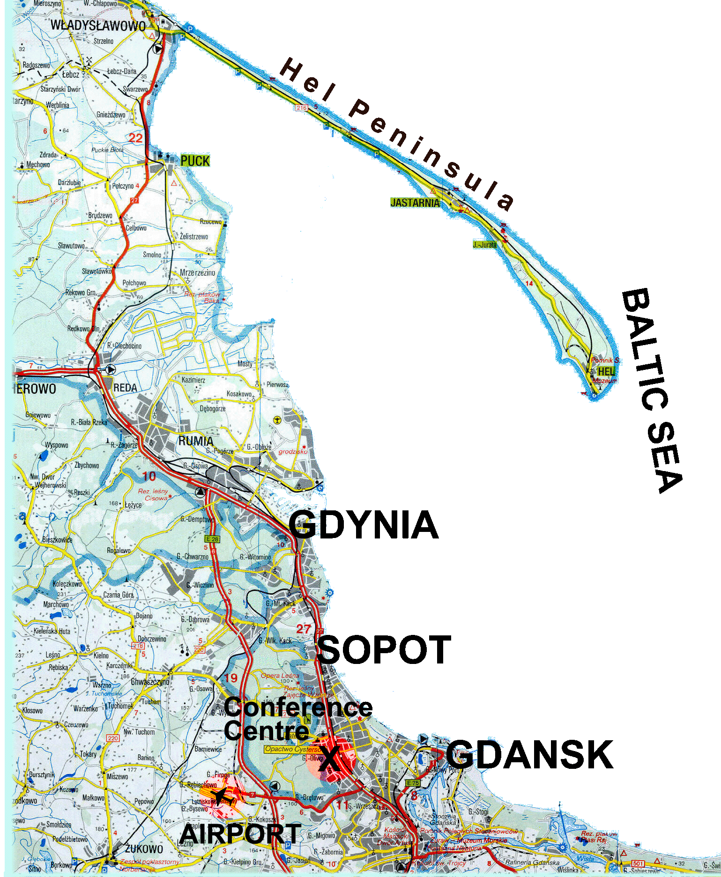

POSEJDON ***
Kapliczna 30,80-341 Gdansk
Best prices: 40 - 76 EUR
NOVOTEL MARINA ***
Jelitkowska St. 2080-342 Gdansk
Best prices: 46 - 83 EUR

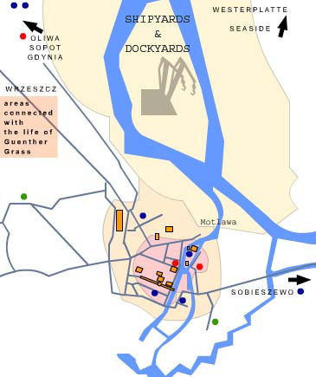
DWOR OLIWSKI *****
Bytowska 480-328 Gdansk
Best prices: 69 - 149 EUR
Renusz ***
Nadwislanska 56,80-680 Gdansk - Sobieszewo
Best prices: 38 - 106 EUR
Podewils *****
Szafarnia 2,80-755 Gdansk
Best prices: 102 - 719 E
ANGELA GUESTHOUSE **
Bethovena 1280-157 Gdansk
Best prices: 28 - 66 EUR
Dom Muzyka **
Lakowa 1-2, 80-743 Gdansk
Best prices: 33 - 74 EUR
HANZA ****
Tokarska 6, 80-888 Gdansk
Best prices: 93 - 258 EUR
Mercuri Hevelius ***
Heweliusza 22,80-890 Gdansk
Best prices: 59 - 93 EUR
KROLEWSKI ***
Wyspa Olowianka, ul. Olowianka, 180-751 Gdansk
Best prices: 61 - 154 EUR
NOVOTEL CENTRUM ***
Pszenna 1,80-749 Gdansk
Best prices: 42 - 78 EUR

